**CST8256 Web Programming Language I**

Lab 4

# Objective

1. Use Visual Studio SQL Server Object Explorer to manage SQL Server databases
2. Use Microsoft Entity Framework to generate entity classes.

# Due Date

See Brightspace posting for the due date. To earn 5 points, you are required:

1. Complete the lab as required.
2. Zip your **website** into a zip file and submit the zip file to the Canvas.
3. Demonstrate your lab work during the following week’s lab session.

# Requirements

This lab is the prequel of Lab 5, Download and zip a partially completed website **Lab5.zip.**

1. Configure and Manage SQL Server with Visual Studio

As an IDE, Visual Studio comes with all functionality/tools for developers to work with databases from different vendors, by default Microsoft SQL Server, of course.

Likely, you may already have one or more instances of MS SQL Server installed on your machine. To find out the details of these SQL Server instances, you can use Visual Studio’s **SQL Server Object Browser** (select menu item “View > SQL Server Object Browser”)

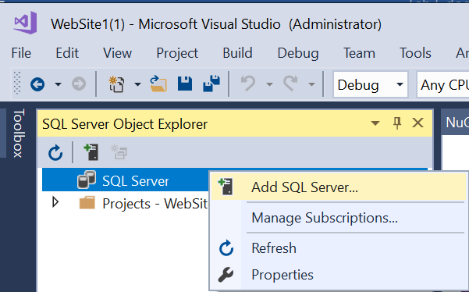

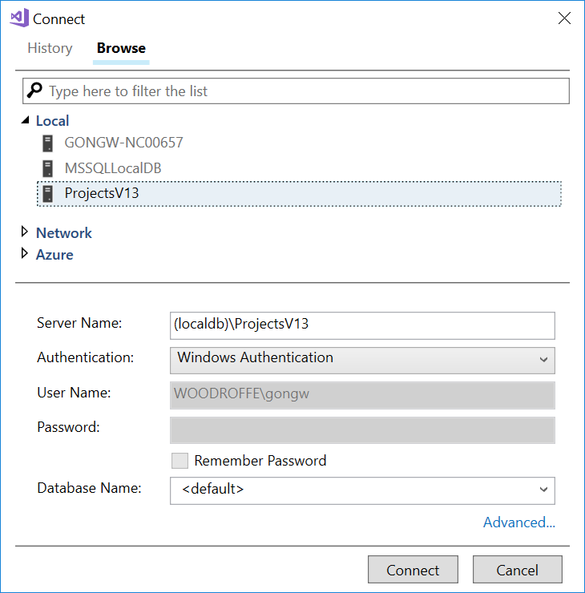

Note: In my case, there are three SQL Server instances running on my computer:

* **GONGW-NC00657** came with **MS SQL Server 2016**. If your laptop does not have **MS SQL Server** installed, you will not have this instance. This instance may not automatically start when Windows starts. If it is not started, Visual Studio will not be able to connect to it. You can use SQL Server Configuration Manager to start or stop it.
* **MSSQLLocalDB** came with Visual Studio 2017 or a later update version of Visual Studio 2015. You may not have this instance if you do not have VS2017.
* **(localdb)\ProjectsV13** came with Visual Studio 2015.
* If you previously installed early version of Visual Studio, you may have other versions of SQL Server such as (localdb)\V11.0 or (localdb)\V12.0 etc.

If you do not have any of above instances, you need to re-run Visual Studio installation program to modify features to add components as follows:

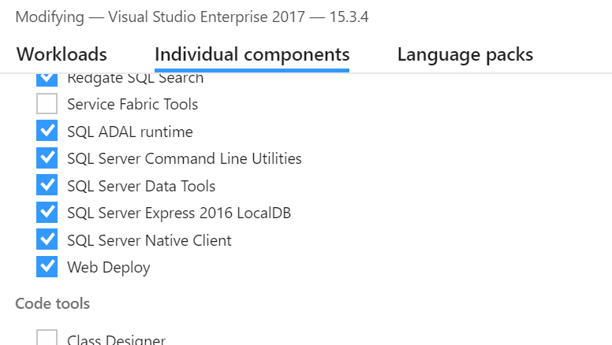

LocalDB is a version of SQL Server specially designed for use by developers. You can use either **MSSQLLocalDB** (if it exists on your laptop) or **ProjectsV13**.

After adding SQL Servers, your SQL Server Object Explorer should look similar to the following:

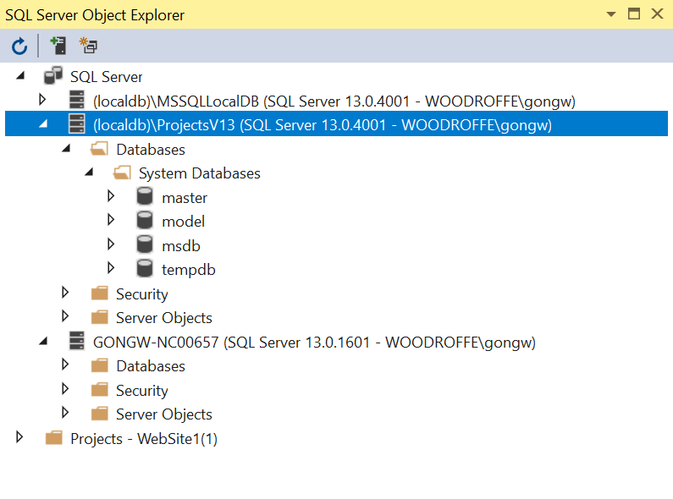

Create a new database **StudentRecord**

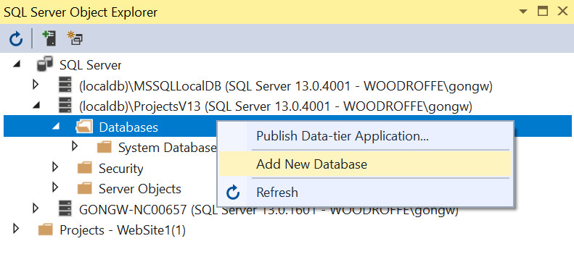

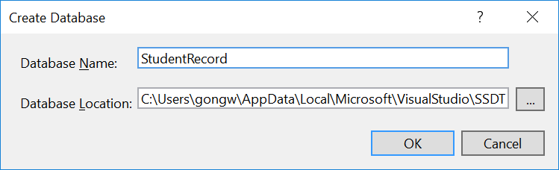

Once the database is created, run **Lab 5 DBBuilder.sql** (select menu **File > Open …**  to open the file and then click the run button) to create tables for use in lab 5. You will received a couple of error messages when you run this SQL script the first time. They come from dropping tables not existing yet. You can ignor these error messages. Once the tables are created in the database, you will not receive these error when running the script again.

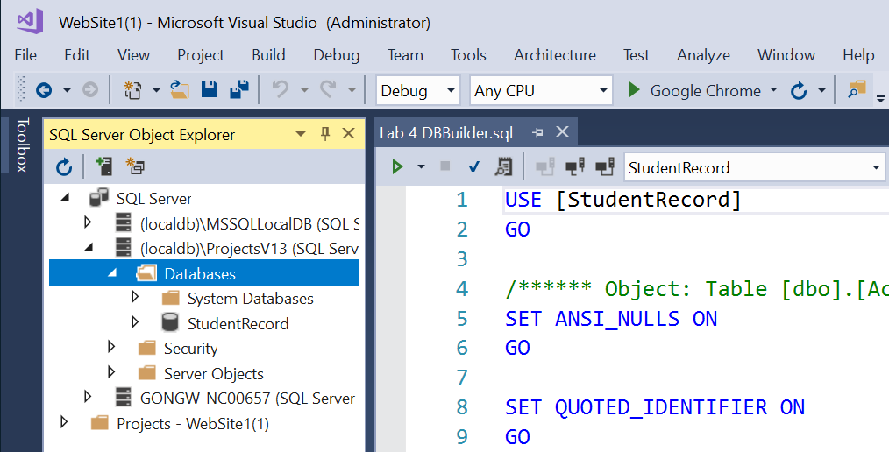

Expend the Tables folder of **StudentRecord**, you should see four tables as below:

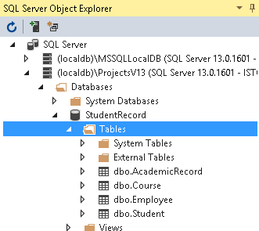

1. Update the build target for the solution.  
   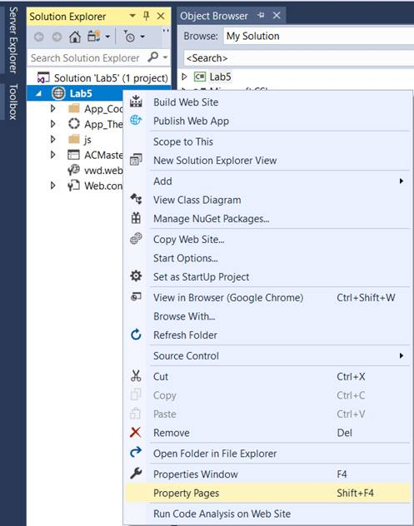  
   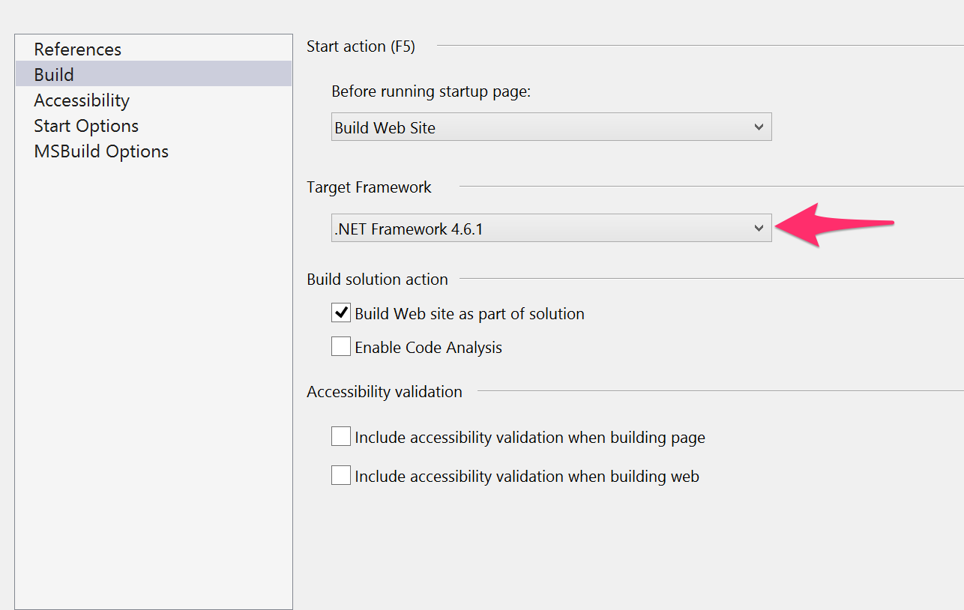  
   Change the Target Framework to 4.6.1
2. Install Microsoft **Entity Framework**

This lab does not have any programming task. Instead, it is to prepare for lab 5. Download and unzip the partially completed Website Lab 5 from Canvas. Open the website Lab 5 and follow the steps below to install add Entity Framework to Lab 5.

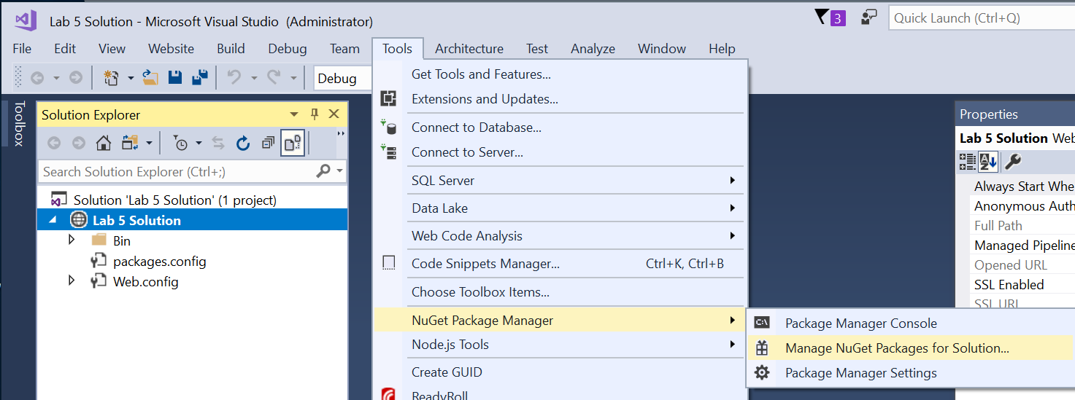

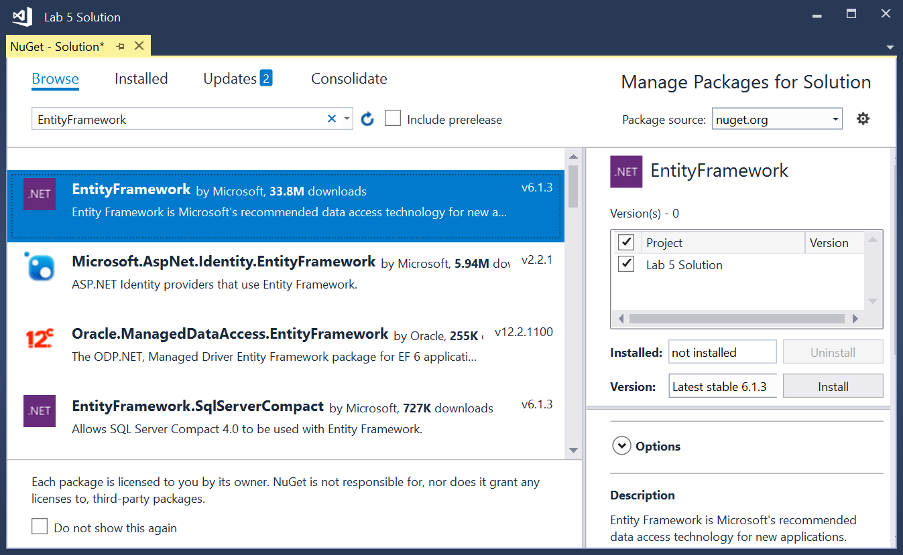

After adding the Entity Framework to the website’s solution, it’s been folder should contain Entity Framework’s DLLs as below:

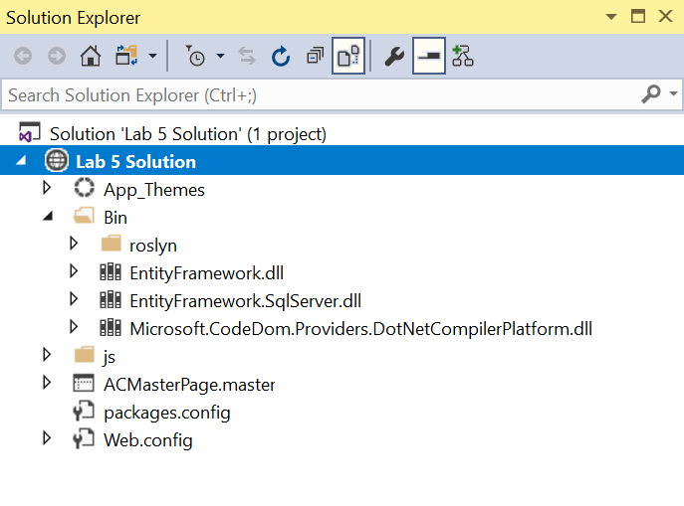

1. Generate the code from the database **StudentRecord**

The first step to use the Entity Framework is adding an entity data model to your website.

Add **App_Code** folder to Lab 5 website if not yet. Add a folder **StudentRecordDal** (stands for Student Record Data Access Layer). Right click the new folder and select **Add > Add New Item …**

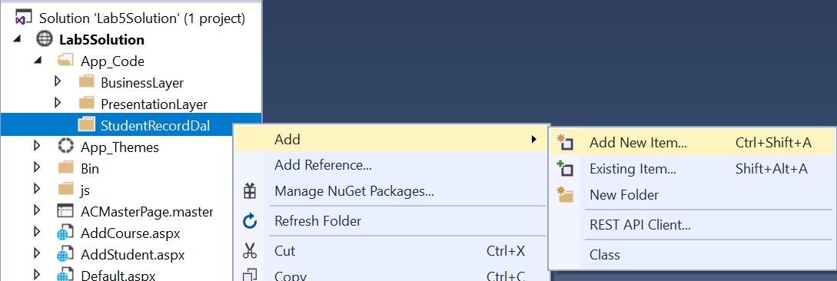

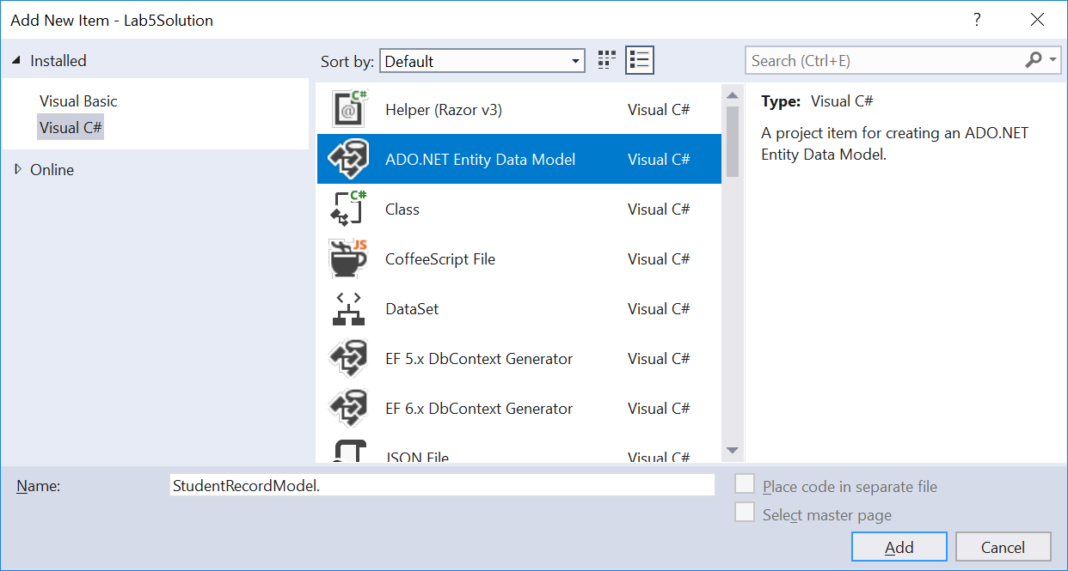

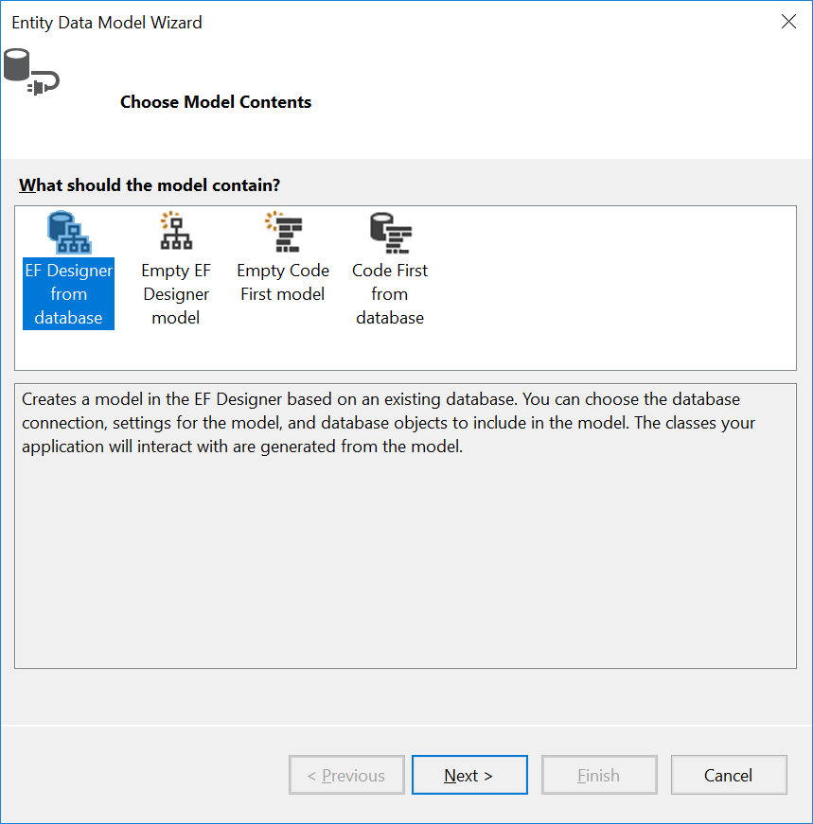

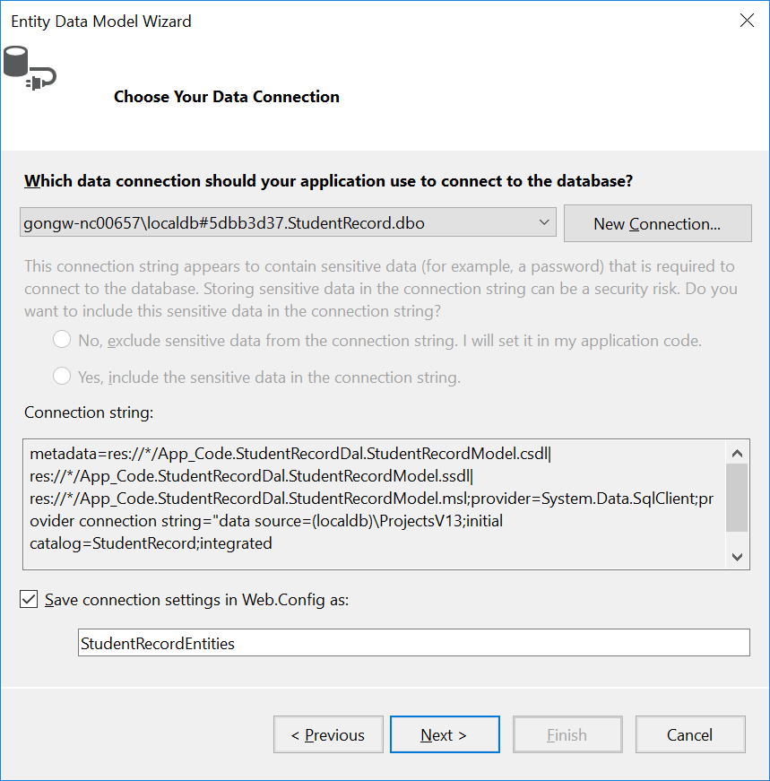

Lab 5 will not use data in Employee table, so you can uncheck Employee table as below.

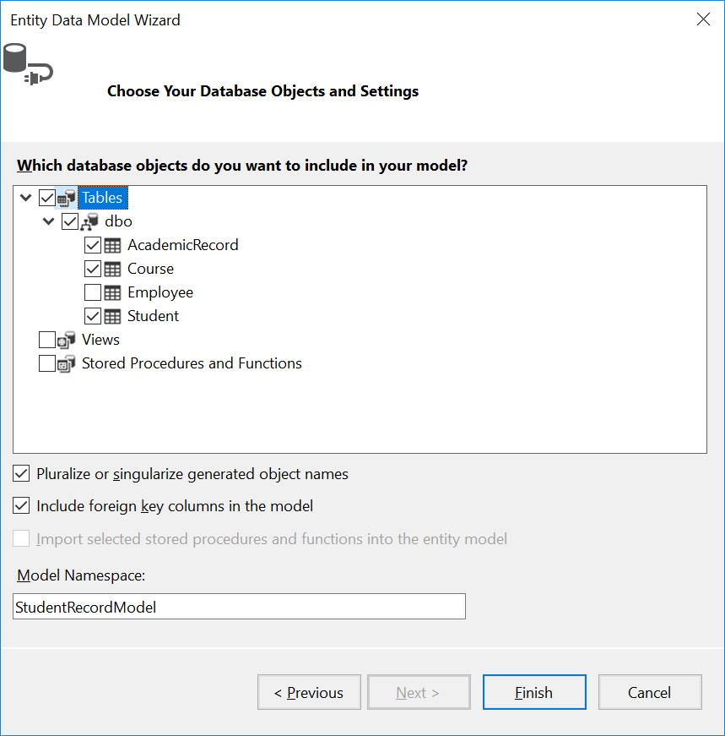

You may receive a couple of warnings like this. Click OK to continue.

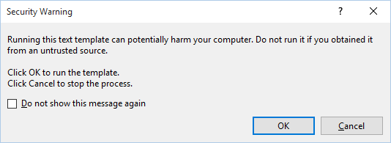

The Entity Framework will generate the Entity Object Model based on the selected tables as:

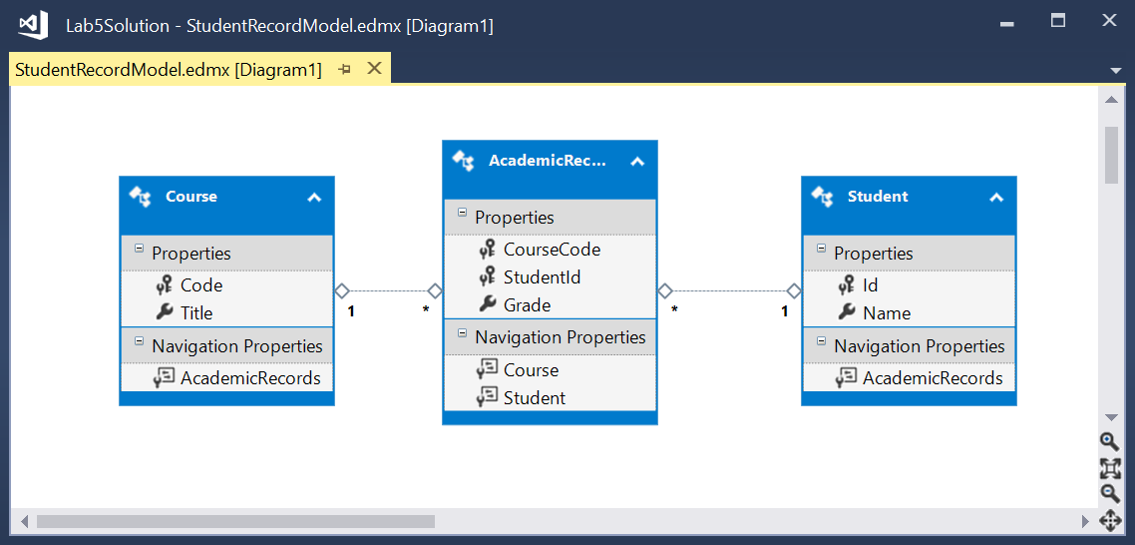

Entity Framework also generated a set of files inside the folder:

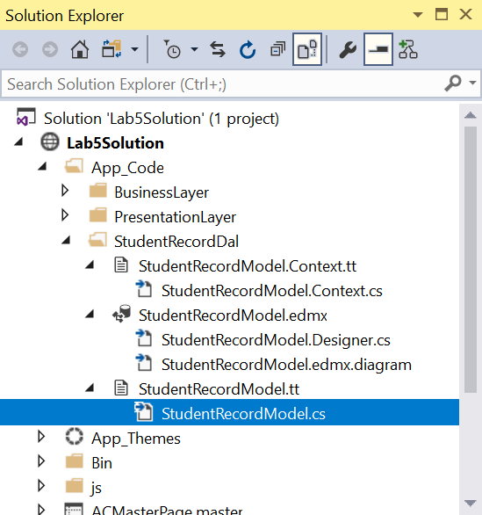

Review the contents of generated file **StudentRecordModel.cs**